Thank you for buying the **Scratch Me**, we hope it will help you in your project.

If you liked our product, do not forget to rate it in an Asset store: <http://u3d.as/1WE2>.

Your feedback will help me improve the project.

If you have any suggestions or questions, you can write to this email: [*pirate.parrot.software@gmail.com*](mailto:pirate.parrot.software@gmail.com)

**1.0 Components list**

**Scratch image** – scratch component that should be used wethewer you are using unity UI for your scratch card.

**Scratch sprite** – scratch component that should be used with sprite-scratch object.

**2.0 Setup**

**2.1 Scratch image setup**

In order to create scratch image select it from UI creation menu like it’s shown below:

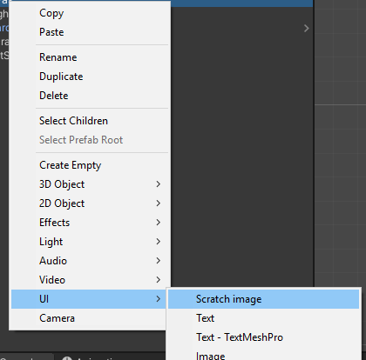

The object with the Scratch Image component will be created:

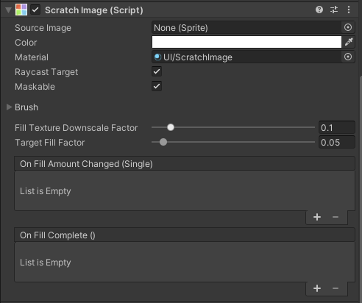

You can use it in the same way as the conventional UI image. All the settings of the standard UI image is applicable here reffer for them to the unity manual. Also as it’s derived from *UnityEngine.Image* you can use it in all sitations which reqires image.

**2.2 Scratch sprite setup**

In order to create scratch sprite select it from 2D Object creation menu like it’s shown below:

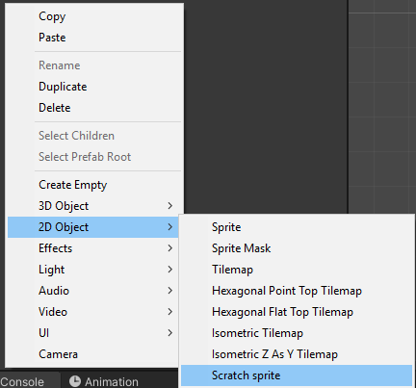

The object with all reqired components will be created:

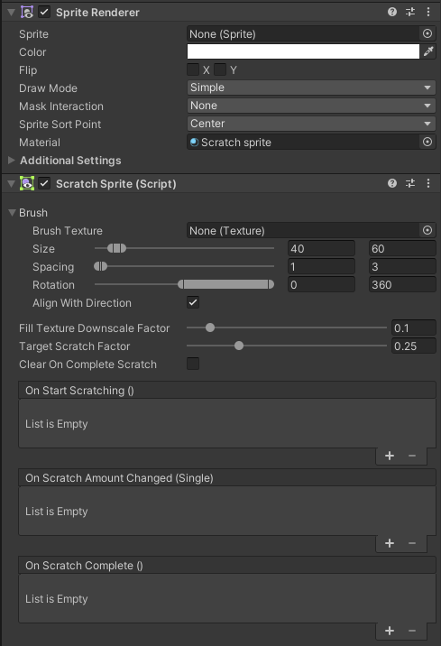

Please note that in order for scratch to work with sprites you should also add and configure Collider2D to your sprite and add Pysics2DRaycaster to your camera setup.

**3.0 Settings**

The settings of both of the objects are the same so we will cover them together.

All float parameters can be set to range. The value will be randomly selected between min and max value.

**3.1 Brush section**

You can easily customize brush to your needs by tweeking the brush settings

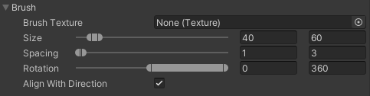

**Brush texture:** You can set any texture you like to make scratch different. If it’s set to none, the default brush will be used. The texture should be rectangular black and white image like the one below:

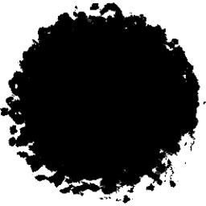

There are several brushes made for your use located at ‘Textures/Brushes’ folder inside the package:

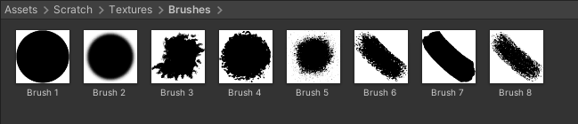

**Example:**

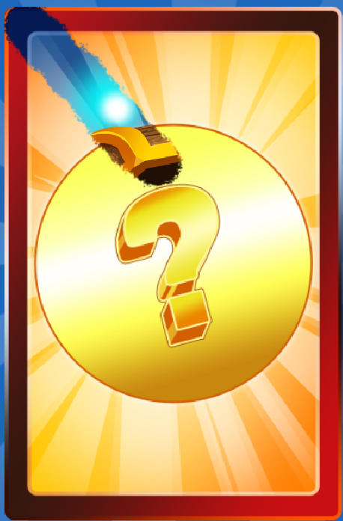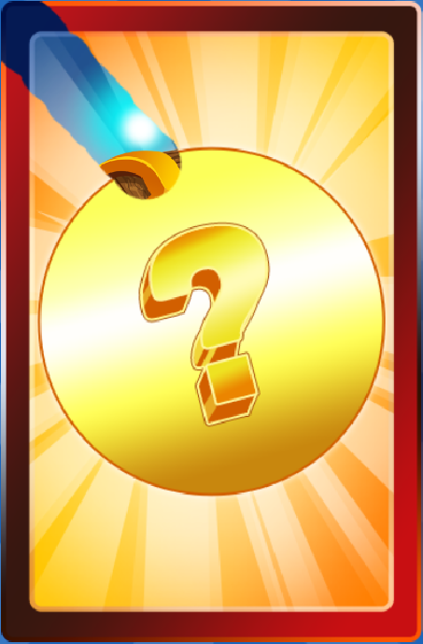

Default brush vs Circular brush

**Size:** By changing brush size you are changing area that your brush is scratching.

**Example:**

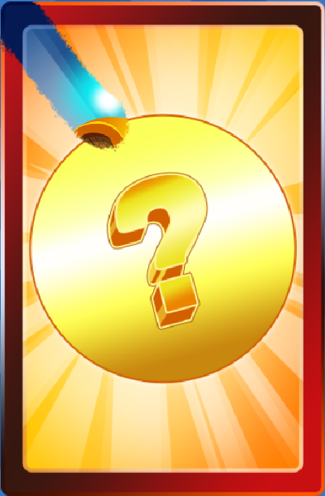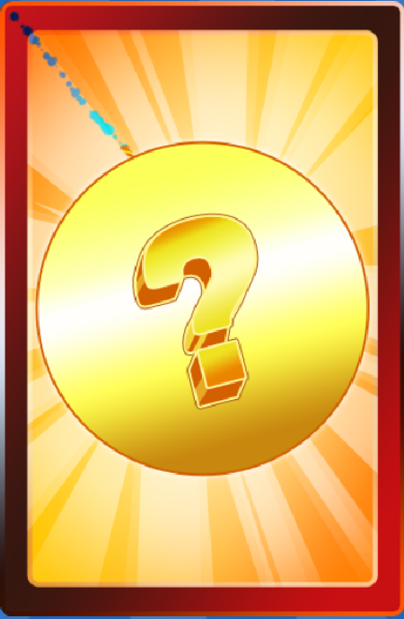

Brush size 40-60 vs brush size 1-10

**Spacing:** Spacing is defining how far away will each brush stroke appear.

**Example:**

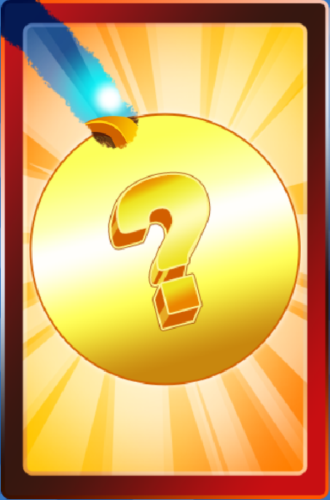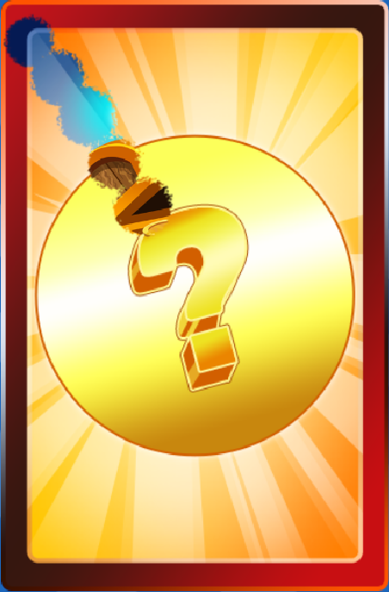

Spacing 1-3 vs 20-30

**Rotation:** How randomized rotation of the brush strokes will be.

**Example:**

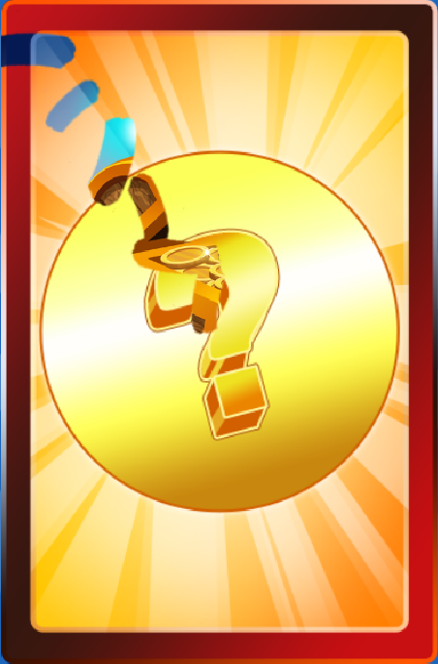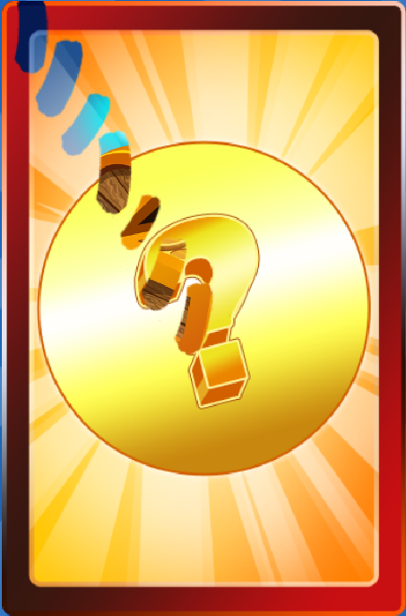

Rotation 0-360 vs 0-0

(Spacing increased to show the difference better)

**Align with direction:** Defines wether the brush will be aligned to the direction of the stroke.

**Example:**

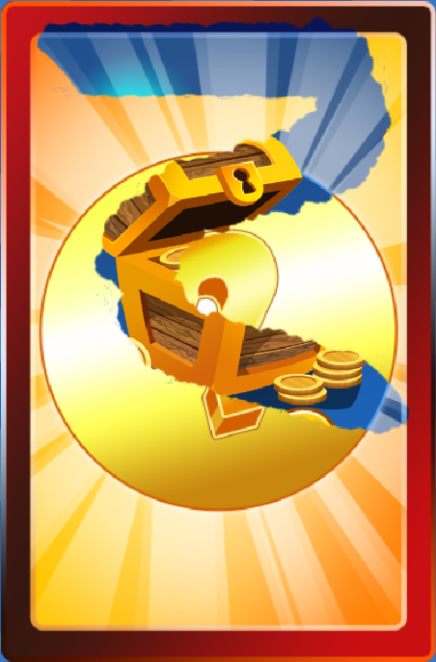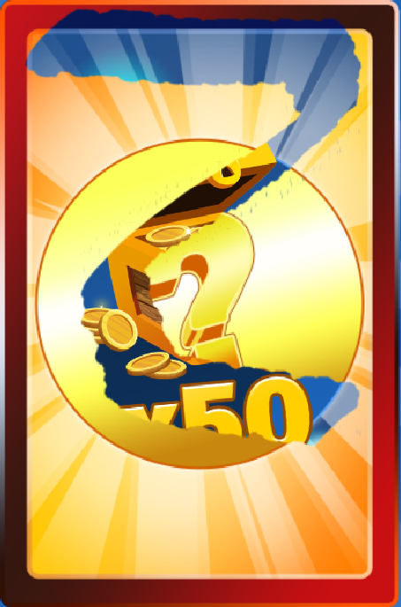

On vs Off

**3.2 Other settings**



**Fill texture downscale factor**: determines now much will check buffer downscaled. The less it is the better performance will be. Generaly 0.1 is enough for any situation.

**Target scratch factor**: how much of the scratch card should be erased in order to count as complete.

**Clear on complete scratch**: determines wether the scratch image will be fully cleared after reaching target fill factor.

**3.3 Events**

There are three events that will be fired when scratch amount changes:

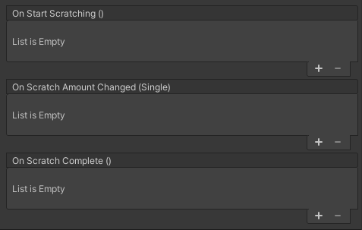

**OnStartScratching** –invokes when you are start scratching the card.

**OnScratchAmountChanged** – invokes when you are scratching the texture and reduce it scratch amount and when you clear your scratch. Provides value between 0.0f-1.0f where 0.0f is fully scratched.

**OnScratchComplete** – invokes when your scratch amount is less than target scratch factor. Can be used to complete scratching and give a player reward.

Thank you for buying the **Scratch Me**, we hope it will help you in your project.

If you liked our product, do not forget to rate it in an Asset store: <http://u3d.as/1WE2>.

Your feedback will help me improve the project.

If you have any suggestions or questions, you can write to this email: [*pirate.parrot.software@gmail.com*](mailto:pirate.parrot.software@gmail.com)